Software Requirements Specification
for
Hostel Management System
Version 1.0 approved.
Prepared by:
- MUHAMMAD MUSA KIANI
- AJMAL KHAN
Organization: D Capital Boys Hostel Bara Kahu
13 June 2024
Table of Contents
Table of Contents ii
Revision History ii
1. Abstract 3
1.1 Preface 3
1.2 Executive Summary 4

2. General Introduction 5

3. Use Case Diagram 7
3.1 System Activity Diagram 8
3.2 Use Case Forms and Activity Diagram 38

4. Component Diagram 42
4.1 Description 4

5. Class Diagram 45
5.1 Description 46

6. Sequence Diagram 53

7. State Diagram 58

7.1. State Description 60

Revision History
Name | Date | Reason For Changes | Version
Final Report | 13/6/2024 | Final and Updated Version of all the Documents. | V.1.4

Preface
This Software Requirements Specification (SRS) document defines the functional and non-functional requirements for the Hostel Management System (HMS). The HMS is a software application designed to automate and streamline the management processes of a hostel facility.
The development of this Hostel Management System is initiated to address the challenges faced by hostel administrators in manually managing student records, room allocations, and fee collections. By implementing an automated system, we aim to eliminate manual errors, reduce paperwork, and provide real-time access to critical hostel-related information.
This document serves as a comprehensive guide for stakeholders involved in the development, testing, and implementation of the Hostel Management System. It defines the functional and non-functional requirements of the system, including system features, user interfaces, performance criteria, and security considerations.
The intended audience for this document includes software developers, project managers, quality assurance engineers, and end-users who will interact with the Hostel Management System. It is essential for all stakeholders to understand the requirements and expectations outlined in this document to ensure the successful development and deployment of the system.
This SRS document will undergo review and approval by the project stakeholders to ensure alignment with the project objectives and user needs. Any subsequent changes or updates to the requirements will be documented and communicated to all relevant parties.

  - Abstract
The Hostel Management System (HMS) is a software application designed to automate and improve the efficiency of managing a hostel facility. This document outlines the functional and non-functional requirements of the HMS. The system aims to address the limitations of manual record-keeping and streamline processes for hostel staff, administrators, and potentially students (depending on the specific design).
Key features of the Hostel Management System include student registration, which allows hostel administrators to maintain detailed records of students, including personal information, contact details, and academic details. The system facilitates the allocation of hostel rooms based on predefined criteria such as room capacity, preferences, and availability, ensuring optimal utilization of hostel resources.
Additionally, the system automates the fee management process, enabling administrators to generate invoices, track payments, and manage overdue accounts efficiently. Students can access the system to view their room allocation status, make fee payments online, and submit requests or complaints related to hostel facilities. The system also enhances communication between students and administrators through integrated messaging features, notifications, and alerts.
The HMS will provide functionalities for managing:
Hostelites Data: Student information, room assignments, applications, and occupancy management.
Rooms and Beds: Availability tracking, room types, and maintenance requests.
Fees and Payments: Rent collection, billing, and tracking of resident payments.
Facilities and Services: Management of hostel amenities, maintenance requests, and access control (if applicable).
Reporting and Analytics: Generation of reports on occupancy rates, fees, and other relevant data.
The overall objective of the HMS is to enhance operational efficiency, improve data accuracy, and provide a user-friendly platform for hostel management. By leveraging technology to automate routine tasks and streamline processes, the system contributes to a more efficient, transparent, and user-centric hostel management experience.

1.2 Executive Summary
The Hostel Management System (HMS) is a software solution designed to revolutionize the way hostel facilities are managed. This document outlines the system's requirements, aiming to automate and streamline daily operations for staff, administrators, and potentially students.

Problem: Traditional, paper-based hostel management is prone to errors, inefficiencies, and time-consuming tasks.

Solution: The HMS offers a comprehensive software solution to manage all aspects of hostel operations, including:

Resident Management: Efficient student record keeping, applications, room allocation, and occupancy tracking.
Room Management: Real-time availability tracking, room types, maintenance requests, and access control (optional).
Financial Management: Automated rent collection, billing, and tracking of resident payments.
Facility Management: Manage hostel amenities, maintenance requests, and inventory control.
Reporting & Analytics: Generate insightful reports on occupancy rates, fees, and other critical data for informed decision-making.

Benefits: The HMS offers significant advantages, including:
Increased Efficiency: Automates tasks, reduces manual work, and streamlines processes.
Improved Accuracy: Minimizes errors associated with manual record-keeping.
Enhanced Transparency: Provides real-time data access for stakeholders.
Better Communication: Facilitates communication between staff, administrators, and potentially students.
Cost Savings: Reduces administrative costs associated with manual processes.
Target Audience: This document is intended for system developers, hostel staff, administrators, and project stakeholders.

2: Introduction to Hostel Management System Project:
In the modern era of technology, managing a hostel efficiently has become imperative to provide a seamless experience for students and staff. A Hostel Management System (HMS) is designed to streamline and automate the day-to-day administrative operations of a hostel. This system addresses the key aspects of hostel management, such as room allocation, fee collection, attendance tracking, and maintenance requests, ensuring a smooth and organized environment.
The Hostel Management System project is a comprehensive software solution that aims to replace traditional, manual methods with a robust, digital approach. It leverages the power of information technology to simplify complex processes, reduce paperwork, and enhance the overall management experience. By centralizing data and providing real-time access to information, the HMS allows administrators to make informed decisions, thereby improving the operational efficiency and satisfaction of residents.
Key features of the Hostel Management System include:
- Room Allocation and Management: Efficiently assigns rooms to students based on predefined criteria and availability, with the ability to manage transfers and track occupancy rates.
- Fee Collection and Management: Automates the fee payment process, generates invoices, tracks payment status, and provides financial reports.
- Maintenance and Complaints Handling: Allows residents to log maintenance requests and complaints, ensuring timely resolution and upkeep of hostel facilities.
- Attendance Tracking: Digital attendance monitoring, including entry and exit records, and generation of attendance reports.

Objectives:
The primary objectives of the Hostel Management System are:
- Efficiency: To streamline the administrative processes involved in hostel management, reducing the time and effort required to perform routine tasks.
- Accuracy: To minimize errors associated with manual data entry and handling, ensuring the accuracy and reliability of hostel records.
- Transparency: To provide a transparent system where all stakeholders have access to relevant information, fostering trust and accountability.
- Accessibility: To ensure that the system is accessible to users from any location, providing real-time access to information and services.
- Security: To protect sensitive data through robust security measures, ensuring the privacy and confidentiality of user information.

3: Use Case Diagram:

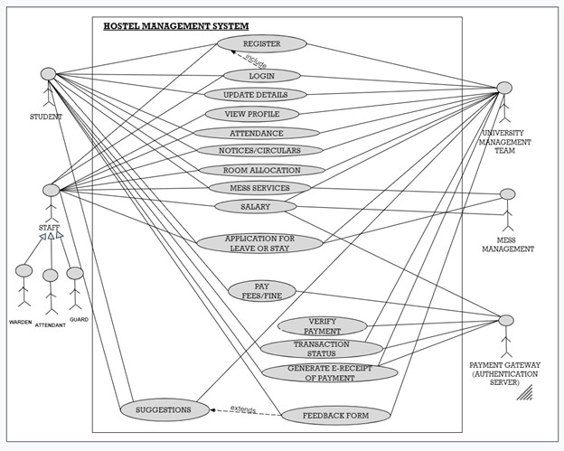

3.1: System Activity Diagram

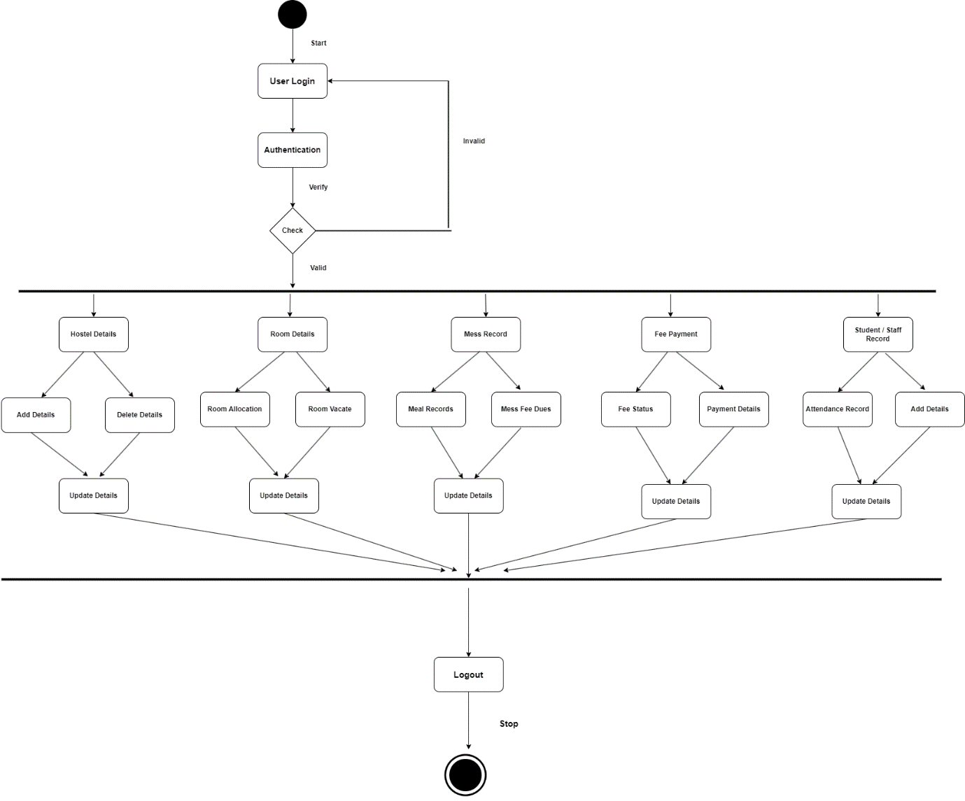

3.2: Use Case Forms:

Use Case Name: Admin Login ID: 1 Importance level: High
Primary Actor: Administrator Use Case Type: Essential
Stackholder and Interest: Administrator - wants to securely access the system to manage users, accounts, and system settings. System - needs to verify the identity of the administrator attempting to login.
Brief Description: This use case describes the process of an administrator logging in to the system.
Trigger: The administrator attempts to access the system by entering a URL or launching the application. Type: Internal
Relationship: Association: Administrator Include: Extend: Generalization:
Normal Flow of Events: 1. The administrator enters their username and password on the login screen. 2. The system authenticates the username and password against a secure user database. 3. If the authentication is successful, the system grants access to the administrator dashboard. 4.If the authentication fails, the system displays an error message and prompts the administrator to try again.
Sub Flow: S-1: Password Reset 1. Administrator enters their username or registered email address. 2. System sends a password reset link or temporary password to the administrator's email. 3. Administrator clicks the link or uses the temporary password to access a password reset page. 4. Administrator enters a new password twice for confirmation. 5. System validates the new password strength and resets the administrator's password. 6. System allows the administrator to login with the new password. S-2: Account Lockout 1. System displays an error message indicating the account is locked. 2. Administrator can contact system administrator for assistance. S-3: Two-Factor Authentication 1. After entering username and password, the system prompts for a secondary authentication factor (e.g., security code sent via SMS, authentication app). 2. Administrator enters the received code. 3. System validates the code and grants access upon successful verification.
Use Case Name: Manage Mess Records ID: 2 Importance level: High
Primary Actor: Hostel Management Staff Use Case Type: Essential
Stackholder and Interest: Hostel Management Staff - wants to efficiently manage meal plans and billing for hostelite Students - want to have a clear record of their mess fees
Brief Description: This use case describes the process of managing mess records for hostelite in a hostel, including adding new residents to the mess, recording meals consumed, generating mess bills, and collecting payments.
Trigger: A hostelite joins the hostel or signs up for the mess facility. Type: Internal
Relationship: Association: Hostel Management Staff Include: Manage Mess Records Extend: Generalization:
Normal Flow of Events: 1. The warden or hostel management staff adds a new resident to the mess list. 2.The system generates a mess account for the resident. 3.The hostelite swipes their ID card or uses a biometric system to record meals consumed. 4.The system tracks the meals consumed by the resident and calculates the mess bill. 5.The warden or hostel management staff generates mess bills for all residents periodically (e.g., monthly). 6.The warden or hostel management staff collects mess fees from students. 7.The system updates the mess account balance for each hostelite.
Sub Flow: S-1: Add New hostelite to Mess 1. Warden/ Staff verifies resident details and mess plan selection (full board, half board, etc.). 2. System creates a mess account for the resident, linking it to their hostel ID. 3. System assigns a unique identifier for meal recording (e.g., ID card, biometric data). S-2: Record Meal Consumed 1. hostelite swipes their ID card or uses a biometric scanner at the entry point. 2. System validates the hostelite ID and mess account status (active/deactivated). 3. System records the meal type (breakfast, lunch, dinner) based on the time of day. S-3: Generate Mess Bill 1. System calculates total meals consumed by each hostelite for the billing period. 2. System applies the hostelite mess plan rate to calculate the mess fee. 3. System adds any additional charges (e.g., guest meals). 4. System generates a detailed mess bill for each resident, including: 1. Hostelite name and ID 2. Billing period 3. Total meals consumed 4. Mess fee amount 5. Any additional charges 6. Due date for payment Collect Mess Fees 1. Staff distributes mess bills to hostelite. 2. Hostelite can pay their mess fees through various methods (e.g., cash, online payment gateway). 3. System validates the payment and updates the hostelite mess account balance. 4. System validates the payment and updates the hostelite mess account balance. 5. Staff may issue receipts for successful payments .

Use Case Name: Room Allocation ID: 3 Importance level: High.
Primary Actor: Hostel Administrator Use Case Type: Essential
Stackholder and Interest: Student - want to secure a hostel room that meets their needs. Hostel Management - wants to efficiently allocate rooms to hostelites.
Brief Description: This use case describes the process of allocating a room to a hostelites based on their registration details and room availability.
Trigger: Student makes a reservation for a room (online portal, by phone, etc.)
Type: External
Relationship: Association: Student Include: Student Information Verification Extend: Generalization: Room Maintenance Check
Normal Flow of Events:
1. The primary actor enters the student reservation details into the system.
2. The system verifies the reservation details and checks room availability for the requested dates and room type.
3. If a room is available, the system allocates a specific room to the student.
4. The system generates a confirmation email or notification for the student.
5. The system updates the room inventory to reflect the room’s occupancy status.
Alternative Flows:
6. If no room is available that meets the student’s needs. The system provides alternative options to the student (e.g., different room type, different dates) and restarts at step 3.
7. The student reservation details are invalid. The system prompts the primary actor to correct the information and restarts at step 1.
Sub Flow:
Room Availability Check: This sub flow verifies if there's a room available that meets the student’s needs (room type, capacity) for the requested dates. It might involve checking the hostel's room inventory system.
Alternative Room Suggestion: If the requested room is unavailable, this sub flow could suggest alternative options to the students, such as different room types, different dates, or nearby partner hostels (if applicable). This might involve presenting the students with available options and restarting the room allocation process with the chosen alternative.
Waitlist Management: Some systems might have a waitlist functionality. If no suitable room is currently available, this sub flow could add the student to a waitlist for their desired room and dates, and notify them if a room becomes available.

Use Case Name: Room Change Request ID: 4 Importance level: Low.
Primary Actor: Student Use Case Type: Essential
Stakeholder and Interest:
Student - Wants to change their assigned room due to various reasons (e.g., noise, incompatible roommate, wanting a single room from a shared room).
Hostel Management - Wants a smooth and efficient room change process to minimize disruption and maximize student satisfaction.
Brief Description: This use case describes the process for a student to submit a request to change their assigned room in the hostel.
Trigger: A student decides they want to change their assigned room.
Type: External
Relationship: Association: Student Include: Student Information Verification Extend: Generalization: Room Maintenance Check
Normal Flow of Events:
1. The student logs in to the hostel management system portal (e.g., mobile app, web interface).
2. The system displays a menu of options for submitting a room change request.
3. The student selects the room change request option.
4. The system presents a form for the student to provide details regarding their room change request. This might include:
Reason for the room change (optional)
Preferred new room type (single, double, etc.) - if applicable
Preferred move-in date (optional)
5. student submits the room change request electronically.
6. The system sends a notification to the hostel management staff (e.g., email, dashboard alert).
7. Hostel management staff reviews the request and room availability.
8. Hostel management staff responds to the student via the system:
9. Approval notification with new room assignment details (room number, move-in date)
10. Denial notification with explanation (e.g., no rooms available, policy restrictions)
11. The system reflects the updated room assignment for the student (if the request is approved).
Sub Flow:
Room Availability Check:
This sub flow verifies if there are rooms available that meet the student's preferences (e.g., desired room type, location).
It might involve checking the hostel's room inventory system for available rooms that match the student's request and considering factors like capacity restrictions or maintenance schedules.
2. Roommate Matching (Optional):
If the student is requesting a move to a shared room, this sub flow could involve identifying a compatible roommate based on preferences (e.g., gender, smoking habits) or a random assignment if no preference system exists.
3. Room Change Cost Calculation (Optional):
Some hostels might have a policy where room changes incur a fee depending on factors like reason for change or proximity to the original assigned room. This sub flow would calculate any associated fees based on pre-defined rules.
4. Student Belongings Move Coordination (Optional):
Depending on the hostel's policy, this sub flow might involve coordinating the student's belongings move to the new room. This could be self-service or involve assistance from hostel staff.
5. Old Room Move-Out Check (Optional):
This sub flow could involve a staff member checking the vacated room for any damages or missing items before assigning it to another student.

Use Case Name: Maintain profiles for hostel staff including wardens, cleaners, maintenance staff, etc. ID: 5 Importance level: High.
Primary Actor: Hostel Administrator (or someone with designated access rights) Use Case Type: Essential
Stakeholder and Interest:
Hostel Management: Wants accurate and up-to-date staff profile information for efficient administration and record-keeping.
Hostel Staff: Wants a system to maintain their personal and employment information accurately.
Brief Description: This use case describes the process for a hostel administrator to create, update, and manage profiles for hostel staff members (wardens, cleaners, maintenance staff, etc.).
Trigger: A new staff member is hired.
An existing staff member's information needs to be updated (e.g., contact details, emergency contact, employment status).
Type: External
Relationship: Association: Staff Member Include: Staff Information Verification Extend: Generalization: Staff Records and Maintanence
Normal Flow of Events:
1. The hostel administrator logs in to the HMS system with their authorized credentials.
2. The system displays a menu of options for staff profile management.
3. The administrator selects the option to create a new staff profile or update an existing one.
4. The system presents a form for entering staff member details. This might include:
5. Personal Information (name, contact details, emergency contact)
6. Employment Details (staff type - warden, cleaner, maintenance etc., start date, job role, contract details)
7. Login Credentials (optional if staff members will have access to the HMS system)
8. The administrator saves the staff profile information.
9. The system generates a confirmation notification for the administrator.
Sub Flow:
Login Credential Management (Optional):
This sub flow would be relevant if staff members have user accounts. It would involve creating, resetting, or managing login credentials for staff to access the HMS system.
Access Control Management (Optional):
This sub flow could be used to define specific access levels for different staff roles within the HMS. For example, wardens might have access to room management features, while cleaners might only have access to tasks related to their cleaning schedules.
Document Management (Optional):
This sub flow could allow attaching relevant documents to staff profiles, such as resumes, contracts, or training certificates.
Notification Management (Optional):
This sub flow could be used to set up automatic notifications for staff members, such as contract expiry reminders or system updates.

Use Case Name: Student registration portal ID: 6 Importance level: High
Primary Actor: Student Use Case Type: Essential
Stackholder and Interest: Student - want to register for a hostel room online Hostel Management - want a streamlined process to register student efficiently
Brief Description: This use case is describe the process a student register for a hostel room online through the hostel management system registration portal.
Trigger: Student visit the hostel management system portal. Type: External
Relationship: Association: Student Include: Extend: Generalization:
Normal Flow of Events: 1. The student starts by logging in to the portal with existing credentials or creating a new account. 2. The student finds a section dedicated to hostel applications. 3. They choose the desired semester/term and hostel preference. 4. The portal guides the student through an electronic application form. 5. This typically includes personal details, academic information, and any supporting documents (e.g., ID proof, medical certificate). 6.Some portals might allow students to pay the application fee or hostel deposit directly during registration (using a secure payment gateway). 7.Once all information is entered and fees paid (if applicable), the student submits the application electronically. 8. The portal provides a confirmation message or reference number for tracking purposes. 9. Hostel administrators receive notifications or access applications submitted through the portal. 10. They review student information and eligibility based on pre-defined criteria. 11. Based on availability and criteria, administrators select students for hostel rooms. 12. The portal might be used to send automated emails notifying students of their application status (accepted, waitlisted, rejected). 13. If the portal integrates further with room management, it might display assigned rooms to selected students. 14. Students might be able to confirm acceptance and schedule check-in dates through the portal.
Sub Flow: 1. User entering details like email address, password, and potentially security questions. 2. System validating the entered information (e.g., email format, password strength). 3. Account creation upon successful validation, potentially with account verification steps (email verification link). 4. Selecting the application term/semester. 5. Filling out sections for personal information (name, contact details). 6. Entering academic information (program, enrollment status). 7. Uploading required documents (acceptance letter, ID proof, medical certificate).

Use Case Name: Complaint Registration
ID: 7
Importance level: medium
Primary Actor: Student
Use Case Type: Essential
Stakeholder and Interest:
- Student - Wants a convenient way to register complaints about hostel facilities or services.
- Hostel Management - Wants a streamlined system to receive, track, and resolve student complaints effectively.
Brief Description: This use case describes the process of a student registering a complaint about the hostel through the hostel management system portal.
Trigger: Student logs in to the hostel management system portal.
Type: External
Relationship: Association
Include: Use Case: Student Registration Portal (UC-1)
Extend: N/A
Generalization: N/A
Normal Flow of Events:
- The student logs in to the portal using their existing credentials. (This step is included from UC-1).
- The student navigates to a dedicated section for complaint registration.
- The portal provides a clear and user-friendly interface for submitting complaints.
- The student selects the category of their complaint (e.g., maintenance, internet, food services).
- The student provides a detailed description of the issue they are facing.
- The system may offer options to upload pictures or documents to provide additional context (optional).
- The student submits the complaint electronically.
- The portal provides the student with a confirmation message and reference number for tracking purposes.
- Hostel administrators receive notifications or access a queue of submitted complaints.
- Administrators review the complaint details and assign it to the appropriate staff member for resolution.
Alternative Flow:
- If the student encounters any difficulties submitting the complaint electronically, they may have the option to contact hostel administration through an alternative channel (e.g., phone, email).

Subflows for Complaint Registration Use Case (UC-8)
Here are some potential subflows for the Complaint Registration Use Case (UC-8):
Subflow 1: Selecting Complaint Category
- The portal presents a list of pre-defined complaint categories (e.g., maintenance, internet, food services, security).
- The student selects the category that best reflects their issue.
- The system may offer sub-categories for more specific issue identification (optional).
Subflow 2: Uploading Supporting Documents (optional)
- The system allows the student to upload photos or documents to provide visual evidence of the complaint (e.g., picture of a broken fixture, screenshot of an internet issue).
- The system may have limitations on file size and format for uploaded documents.
Subflow 3: Alternative Complaint Submission (if applicable)
- The student cannot submit the complaint electronically due to technical difficulties or internet access issues.
- The system provides alternative contact information for hostel administration (e.g., phone number, email address).
- The student contacts hostel staff through the alternative channel to register their complaint.
Subflow 4: Complaint Assignment
- Upon receiving a new complaint, the system notifies hostel administrators or adds it to a queue for review.
- An administrator reviews the complaint details and assigns it to the relevant staff member based on the complaint category (e.g., maintenance technician for a repair request).
- The assigned staff member receives notification and acknowledges the assignment (optional).

Note: This use case (UC-3) relies on the successful completion of UC-1 (Student Registration Portal) as it requires the student to have a valid account in the hostel management system.

Use Case Name: Fee Payment
ID: 8
Importance level: High
Primary Actor: Student
Use Case Type: Essential
Stakeholder and Interest:
- Student - Wants to conveniently pay hostel fees online.
- Hostel Management - Wants efficient fee collection and clear student fee records.
Brief Description: This use case describes the process of a student making hostel fee payments online through the hostel management system portal.
Trigger: Student logs in to the hostel management system portal.
Type: External
Relationship: Association
Include: Use Case: Student Registration Portal (UC-1)
Extend: N/A
Generalization: N/A
Normal Flow of Events:
- The student logs in to the portal using their existing credentials. (This step is included from UC-1).
- The student navigates to a dedicated section for fee payment.
- The portal displays a summary of outstanding fees (e.g., semester fees, hostel deposit).
- The student selects the specific fee(s) they want to pay.
- The portal offers various secure online payment options (e.g., credit card, debit card, e-wallet).
- The student chooses their preferred payment method and enters the required details securely.
- The system validates the student's payment information.
- Upon successful validation, the student authorizes the payment.
- The system processes the payment securely and transmits it to the hostel's designated account.
- The portal provides the student with a confirmation message and receipt for their records.
- The student's fee payment details are automatically updated in the hostel management system.
- Hostel administrators can access real-time reports on fee collection.
Alternative Flow:
- If the online payment fails due to insufficient funds or other reasons, the system informs the student and allows them to retry the payment or choose an alternative payment method (if available).
- The student might have the option to download a payment slip to make an offline payment (e.g., bank deposit).

sSub flows for Fee Payment Use Case (UC-2)
Here are some potential sub flows for the Fee Payment Use Case (UC-2):
Sub flow 1: Selecting Specific Fees
- The portal displays a breakdown of outstanding fees (e.g., semester fee, hostel deposit, meal plan).
- The system allows the student to:
  - Select all outstanding fees for payment.
  - Choose individual fees to pay.
- The system updates the total payable amount based on the selected fees.
Sub flow 2: Secure Online Payment Processing
- The student chooses their preferred payment method (e.g., credit card, debit card, e-wallet).
- The system redirects the student to a secure payment gateway for entering payment details.
- The payment gateway validates the student's information (e.g., card number, CVV).
- The system interacts with the payment gateway to process the transaction securely.
  - This may involve additional steps like 3D Secure authentication for credit cards.
Sub flow 3: Payment Failure and Resolution
- The system receives a failure notification from the payment gateway.
- The system informs the student about the payment failure (e.g., insufficient funds, invalid details).
- The system offers options to the student:
  - Retry the payment with corrected information.
  - Choose a different payment method (if available).
  - Download a payment slip for offline payment (e.g., bank deposit).
Sub flow 4: Offline Payment Processing (if applicable)
- The system generates a payment slip containing relevant information (e.g., student ID, fee amount, due date).
- The student downloads and prints the payment slip.
- The student makes the payment at the designated bank or payment center using the slip.
- Once the hostel receives confirmation of the offline payment (manual or automatic), the student's fee record is updated in the system.
These are just a few examples, and the specific sub flows may vary depending on the functionalities of the hostel management system and available payment options.
Note: This use case (UC-2) relies on the successful completion of UC-1 (Student Registration Portal) as it requires the student to have a valid account in the hostel management system.

Use Case Name: Calculate Meal Charges for Students
ID: 9
Importance level: Medium
Primary Actor: System (Automated process)
Stakeholder and Interest:
- Hostel Management - Wants an automated system to calculate meal charges accurately based on student meal plans or attendance.
- Student - Wants fair and transparent meal billing based on their chosen plan or actual utilization.
Brief Description: This use case describes the automated process for calculating meal charges for students residing in the hostel. The system considers either the student's chosen meal plan or their attendance data to determine the appropriate charges.
Trigger:
- Enrollment period for selecting meal plans (periodic).
- Daily attendance data is recorded (for attendance-based billing).
Type: Internal (triggered by external events)
Relationship: Association
Include: N/A
Extend: N/A
Generalization: N/A
Normal Flow of Events (Meal Plan Based):
- During the enrollment period, students select their preferred meal plan from available options (e.g., full board, half board).
- The system stores the student's chosen meal plan information in their profile.
- At the beginning of each billing period (e.g., semester, month), the system automatically retrieves the student's meal plan data.
- Based on the chosen meal plan configuration (number of meals included per day), the system calculates the associated meal charges for the student.
- The calculated meal charges are added to the student's hostel fee statement for the billing period.
Alternative Flow (Attendance-Based):
- Warden/Attendance Monitor records student attendance data daily (refer to Use Case: Student and Staff Attendance Record - UC-4).
- The system integrates with the attendance recording system to access student meal attendance data.
- The system analyzes the student's attendance data for meal periods (e.g., breakfast, lunch, dinner).
- Based on a pre-defined cost per meal, the system calculates the meal charges incurred by the student based on their attendance.
The calculated meal charges are added to the student's hostel fee statement for the billing period.

Subflows for Calculate Meal Charges Use Case (UC-10)
Here are some potential subflows for the Calculate Meal Charges Use Case (UC-10):
Subflow 1: Meal Plan Selection (Normal Flow)
- The hostel announces the enrollment period for students to select their meal plans.
- The system displays available meal plan options with clear descriptions (e.g., full board with three meals daily, half board with two meals).
- The student logs in to the portal and accesses the meal plan selection section. (This may involve navigating to a specific section or receiving a notification during login).
- The student reviews the available meal plans and chooses their preferred option.
- The system validates the student's selection and stores their chosen meal plan data in their profile.
Subflow 2: Attendance Data Integration (Alternative Flow)
- The hostel utilizes an attendance recording system (refer to UC-4: Student and Staff Attendance Record).
- The system for calculating meal charges establishes a secure connection with the attendance recording system.
- The connection allows the system to access relevant student attendance data for meal periods (e.g., breakfast, lunch, dinner).
Subflow 3: Meal Charge Calculation (Both Flows)
- The system retrieves the student's meal plan data (normal flow) or attendance data (alternative flow).
- Normal Flow: Based on the chosen meal plan configuration (number of meals included per day), the system calculates the associated meal charges for the student. (e.g., full board with 3 meals/day * cost per meal * number of days in billing period).
- Alternative Flow: The system analyzes the student's attendance data for each meal period throughout the billing period.
- The system calculates the total number of meals consumed by the student based on their attendance records.
- The system applies a pre-defined cost per meal to determine the total meal charges for the student.
Subflow 4: Fee Statement Generation
- The system integrates with the hostel fee management module.
- The calculated meal charges are added to the student's overall hostel fee statement for the billing period.
- The student receives notification (e.g., email, portal message) of their updated fee statement.

Note: This use case outlines two alternative methods for calculating meal charges. The specific approach used by a hostel management system will depend on its configuration and policies.

Use Case Name: Online and Offline Fee Payment
ID: 10
Importance level: High
Primary Actor: Student
Use Case Type: Essential
Stakeholder and Interest:
- Student - Wants a convenient and flexible way to pay hostel fees online or through other payment methods.
- Hostel Management - Wants to offer multiple payment options to students and improve fee collection efficiency.
Brief Description: This use case describes the process for students to make hostel fee payments using various methods, including online and offline options.
Trigger: Student receives a notification or invoice for their outstanding hostel fees.
Type: External
Relationship: Association
Include: N/A
Extend: N/A
Generalization: N/A
Normal Flow of Events (Online Payment):
- The student logs in to the hostel management system portal using their existing credentials. (This step can be bypassed for guest payments if applicable).
- The student navigates to a dedicated section for fee payment.
- The portal displays a summary of their outstanding fees (e.g., semester fees, hostel deposit).
- The student selects the specific fee(s) they want to pay.
- The portal offers various secure online payment options (e.g., credit card, debit card, e-wallet).
- The student chooses their preferred payment method and enters the required details securely.
- The system validates the student's payment information.
- Upon successful validation, the student authorizes the payment.
- The system processes the payment securely and transmits it to the hostel's designated account.
- The portal provides the student with a confirmation message and receipt for their records.
- The student's fee payment details are automatically updated in the hostel management system.
Alternative Flow (Offline Payment):
- The student can download a payment slip from the hostel management system portal (if available).
- The payment slip contains details like student information, fee amount, and due date.
- The student visits a designated bank or payment center and presents the payment slip along with the fee amount.
- The bank or payment center processes the fee payment and provides a receipt to the student.
The student may need to submit a copy of the payment receipt to the hostel administration for verification.

Subflows for Online and Offline Fee Payment Use Case (UC-11)
Subflow 1: Selecting Specific Fees (Normal and Alternative Flow)
- The portal displays a breakdown of outstanding fees (e.g., semester fee, hostel deposit, meal plan charges).
- The student can:
  - Select all outstanding fees for payment.
  - Choose individual fees to pay.
- The system updates the total payable amount based on the selected fees.
Subflow 2: Secure Online Payment Processing (Normal Flow)
- The student chooses their preferred online payment method (e.g., credit card, debit card, e-wallet).
- The system redirects the student to a secure payment gateway for entering payment details.
- The payment gateway validates the student's information (e.g., card number, CVV).
- The system interacts with the payment gateway to process the transaction securely.
  - This may involve additional steps like 3D Secure authentication for credit cards.
Subflow 3: Offline Payment Process (Alternative Flow)
- The student chooses the option to download a payment slip.
- The system generates a payment slip containing relevant information (e.g., student ID, fee amount, due date, designated payment locations).
- The student downloads and prints the payment slip.
- The student visits a designated bank or payment center listed on the slip.
- The student presents the payment slip along with the fee amount to the bank teller or cashier.
- The bank or payment center processes the payment and provides the student with a receipt.
Subflow 4: Offline Payment Verification (Alternative Flow)
- The student may be required to submit a copy of the bank receipt to the hostel administration for verification. (This step may vary depending on hostel policy).
- Hostel administration verifies the receipt and updates the student's fee payment record in the system.

Note: This use case emphasizes offering both online and offline payment options to cater to students with varying preferences and access to technology.

Use Case Name: Student and Staff Attendance Record
ID: 11
Importance level: High
Primary Actor: Warden/Attendance Monitor (Staff)
Alternative Actor: Student (for self-service attendance)
Use Case Type: Essential
Stakeholder and Interest:
- Hostel Management - Wants to maintain accurate and reliable attendance records for students and staff.
- Warden/Attendance Monitor - Needs a streamlined system to record attendance efficiently.
- Student (for self-service): Wants a convenient way to record their attendance (optional).
Brief Description: This use case describes the process of recording attendance for students and staff residing or working in the hostel.
Trigger:
- Warden/Attendance Monitor: Starts their shift or designated attendance recording time.
- Student (for self-service): Logs in to the hostel management system portal (optional).
Type: External
Relationship: Association
Include: N/A
Extend: N/A
Generalization: N/A
Normal Flow of Events (Warden/Attendance Monitor):
- The warden/attendance monitor logs in to the hostel management system using their staff credentials.
- The system displays a user interface for attendance recording.
- The warden/attendance monitor selects the appropriate date and attendance type (e.g., morning check-in, evening roll call).
- The system displays a list of students or staff residing/working in the hostel (depending on attendance type).
- The warden/attendance monitor marks the attendance status for each individual (present, absent, leave).
- The system allows the warden/attendance monitor to record additional information, if necessary (e.g., reason for absence).
- The warden/attendance monitor submits the attendance record electronically.
- The system stores the attendance data securely in the hostel management system database.
Alternative Flow (Student Self-Service):
- The student logs in to the hostel management system portal using their existing credentials (optional).
- The portal provides a dedicated section for self-service attendance recording (optional).
- The student selects the appropriate date and attendance type (if applicable).
- The system verifies the student's identity and allows them to record their attendance electronically (e.g., through a mobile app).
- The system automatically updates the student's attendance record in the database.

Subflows for Student and Staff Attendance Record Use Case (UC-9)
Subflow 1: Warden/Attendance Monitor Login
- The warden/attendance monitor accesses the hostel management system login page.
- They enter their valid staff credentials (username and password).
- The system authenticates the credentials and grants access to the staff portal.
Subflow 2: Selecting Attendance Type (Warden/Attendance Monitor)
- The warden/attendance monitor navigates to the attendance recording section.
- The system displays a menu or options for selecting the attendance type (e.g., morning check-in, evening roll call, specific event attendance).
- The warden/attendance monitor chooses the appropriate attendance type based on the situation.
Subflow 3: Attendance Marking (Warden/Attendance Monitor)
- The system displays a list of students or staff members depending on the chosen attendance type (e.g., list of residents for morning check-in).
- The warden/attendance monitor reviews the list and marks the attendance status for each individual (present, absent, leave).
  - The system may offer options to quickly mark attendance for all or select groups (e.g., mark all present, mark all absent).
- For students marked absent or on leave, the warden/attendance monitor may be able to record additional information (optional).
  - This could include reason for absence, expected return date, or any notes.
Subflow 4: Student Self-Service Login (Optional)
- The student logs in to the hostel management system portal using their existing credentials.
- The system authenticates the student's credentials and grants access to the student portal.
Subflow 5: Self-Service Attendance Recording (Optional)
- The student navigates to a dedicated section for self-service attendance recording (if available).
- The system may require the student to select the specific date and/or attendance type (if applicable).
- The system verifies the student's identity through a secure method (e.g., entering a PIN, using a mobile app with location services).
- Upon successful verification, the system allows the student to record their attendance electronically (e.g., button click, geo-fencing).
Subflow 6: Attendance Data Storage
- Regardless of the recording method (warden/monitor or student self-service), the system securely stores the attendance data in the hostel management system database.
- The data includes details like student/staff ID, date, time, attendance status, and any additional notes (if applicable).

Note: This use case prioritizes the Warden/Attendance Monitor as the primary actor for recording attendance. The Student self-service option is an alternative functionality that may not be available in all hostel management systems.

Use Case Name: Admin Login
Participating Actors: Admin (Primary Actor)
Flow of Events:
- The admin accesses the login page of the hostel management system. This page should be secure (HTTPS) and clearly labeled as "Admin Login" or similar.
- The admin enters their username and password into the designated fields.
- Username: This could be an email address, employee ID, or a unique username assigned to the admin.
- Password: The password field should obscure the characters as they are typed for security. There should also be a mechanism to retrieve a forgotten password.
- The admin clicks the login button. A clear button labeled "Login" or "Sign In" allows the admin to submit their credentials for authentication.
- The system authenticates the admin’s credentials. The system validates the username and password against a secure database of authorized admins.
- Success: If the credentials are valid, the system grants the admin access to the admin panel. This might involve a redirect to a separate admin dashboard.
- Failure: If the credentials are invalid, the system displays an error message in a clear and concise way. This message should not reveal any specific details about why the login failed (e.g., "Invalid username" or "Incorrect password").
Entry Conditions:
- The admin has a valid username and password for the hostel management system.
- The admin has a device (computer, phone, etc.) with internet access.
Exit Conditions:
- The admin is logged in to the hostel management system and can access the admin panel.
- The admin panel allows the admin to perform a variety of tasks, such as:
- Managing user accounts (residents, staff)
- Configuring system settings
- Viewing system logs
- Managing rooms and bed assignments
- Managing fees and payments
- Generating reports
- The login attempt fails, and the admin is unable to access the system.

Quality Requirements:

- The login page should be secure (HTTPS) and use strong encryption to protect user credentials.
- The system should respond to login attempts quickly (e.g., within a few seconds).
- The system should implement security measures to prevent unauthorized access, such as:
- Strong password requirements: Enforce minimum length and character complexity requirements for passwords.
- Account lockout: Lock an account after a certain number of failed login attempts.
- The system should clearly indicate login failures without revealing specific details about why the login failed.
Use Case Name: Manage Mess Records
Participating Actors: Admin (Primary Actor)
Flow of Events:
- The admin accesses the Mess Records section of the hostel management system. This section may be located within the admin panel.
- The system displays a list of existing mess records. This list may include details like student names, meal plans, dietary restrictions, and outstanding fees (if any).
- The admin can perform various actions on the mess records depending on the system's functionality:
- View Details: Select a specific student's record to view detailed information, including meal consumption history, allergies, and any special dietary needs.
- Add Record: Create a new mess record for a new resident entering the hostel. This may involve specifying their meal plan, dietary restrictions, and any initial fees.
- Edit Record: Modify an existing mess record. This could involve updating a student's meal plan, dietary restrictions, or outstanding fees.
- Delete Record: Remove a mess record for a resident who is no longer staying at the hostel.
- Search/Filter: Search for specific mess records based on student name, room number, or other relevant criteria.
Entry Conditions:
- The admin is logged in to the hostel management system with appropriate access rights.
- The mess records module is functional within the system.
Exit Conditions:
- The admin successfully views, adds, edits, deletes, or searches for mess records.
- The admin encounters an error message if attempting an unauthorized action or if the system malfunctions.

Quality Requirements:

- The mess records interface should be user-friendly and easy for authorized admins to navigate.
- The system should accurately store and display mess record information.
- The system should enforce data integrity rules to ensure consistency and prevent invalid entries (e.g., only allowing valid meal plan options).
- The system should provide clear confirmation messages upon successful actions (adding, editing, deleting records).
- The system should implement proper authorization checks to restrict access to sensitive information and actions based on user roles.
Use Case Name: Room Allocation
Participating Actors: Hostel Administrator (Primary Actor)
Flow of Events:
- The Hostel Administrator initiates the room allocation process by entering the student reservation details into the system.
- The system verifies the entered student reservation details.
- The system checks room availability for the requested dates and room type.
If a room is available:
- The system allocates a specific room to the student.
- The system generates a confirmation email or notification for the student.
- The system updates the room inventory to reflect the room’s occupancy status.
If no room is available:
- The system provides alternative options for the student (e.g., different room type, different dates). (This could involve checking the hostel's room inventory system.)
- The system restarts at step 3 after the student selects an alternative (if applicable).
Entry Conditions:
The Hostel Administrator is logged into the hostel management system.
Exit Conditions:
The room allocation process is successful, and a room is allocated to the student, with a confirmation sent to the student (successful exit).
The room allocation process is unsuccessful because no room is available that meets the student's needs (unsuccessful exit).
Quality Requirements:

The system should acknowledge the room allocation request within a specified time frame (e.g., 30 seconds).
The system should allocate a room to the student or provide alternative options promptly (e.g., within a minute).
The system should accurately reflect the room inventory and update it accordingly.
Use Case Name: Room Change
Participating Actors:
Hostel Resident (Primary Actor)
Hostel Administrator (Optional Actor)
Flow of Events:

- The Hostel Resident initiates the room change request by entering a request through the hostel management system (e.g., online portal, mobile app). The request might include the reason for the change and the desired new room (if known).
- The system verifies the Hostel Resident's identity and validates the request.
- The system checks room availability for the desired new room and dates (if provided by the resident).
If a room is available:
- The system initiates the room change process (which might involve updating room assignments, inventory, access permissions, etc.).
- The system notifies the Hostel Resident of the approval and provides any additional information (e.g., move-in instructions).
If no room is available:
- The system provides alternative options to the resident (e.g., different room type, different dates) or informs them of a waitlist process (if applicable).
- The system may allow the resident to indicate their preferences for the alternative options.
(Optional) The Hostel Administrator reviews the room change request and may approve or deny it based on specific criteria (e.g., availability, residency regulations). They might also communicate with the resident to discuss alternative options.
Entry Conditions:

The Hostel Resident is logged into the hostel management system (if applicable).
The resident has a valid room assignment in the hostel.
Exit Conditions:

The room change request is successful, and the resident is moved to a new room (successful exit).
The room change request is denied (unsuccessful exit).
Quality Requirements:

The system should acknowledge the room change request within a specified time frame (e.g., 30 seconds).
The system should process the room change request efficiently (e.g., within a few minutes). This may include processing time for the initial request, checking availability, and any manual review by a hostel administrator.
The system should communicate the status of the request clearly to the resident (e.g., approval, denial, waitlist status).
The system should update room assignments and inventory accurately to reflect the room change.
Use Case Name: Manage Staff Record
Participating Actors: Hostel Administrator (Primary Actor)
Flow of Events:
1. The Hostel Administrator initiates the staff record management process by selecting the desired action (e.g., create, update, view, delete) for a staff record in the system.
2. The system displays a staff record form depending on the chosen action.
Create: The form allows entering new staff member details (e.g., name, contact information, emergency contact, role, department).
Update: The system retrieves an existing staff member record and allows modifying the details.
View: The system retrieves and displays an existing staff member record.
Delete: The system prompts for confirmation before deleting a staff member record.
3. The Hostel Administrator completes the form (adding new information, modifying existing information, or confirming deletion).
4. The system validates the entered information (e.g., required fields, data format).
5. The system saves the changes to the staff member record database (for create and update actions) or deletes the record (for delete action).
6. The system provides a confirmation message to the Hostel Administrator indicating the success or failure of the operation.
Entry Conditions:
The Hostel Administrator is logged into the hostel management system.
The Hostel Administrator has sufficient permission to manage staff records (e.g., create, update, delete).
Exit Conditions:
The staff record management process is successful, and the staff record is created, updated, viewed, or deleted as intended (successful exit).
The staff record management process fails due to invalid information or insufficient permissions (unsuccessful exit).
Quality Requirements:
The system should provide a user-friendly interface for managing staff records.
The system should accurately capture and store staff member information.
The system should enforce data validation rules to ensure the accuracy and integrity of staff records.
The system should restrict access to staff record management functions based on user permissions.
The system should provide clear feedback to the Hostel Administrator on the outcome of their actions (e.g., success messages, error messages).

Use Case Name: Hostel Complaint Registration
Participating Actors: Student (Primary Actor)

Flow of Events:
- The student accesses the Complaint Registration Portal of the hostel management system. This portal can be a separate website or a dedicated section within a larger system.
- The student chooses the complaint category (e.g., maintenance, noise, housekeeping, internet issues).
- The system presents a complaint form. The form may capture details such as:
  - Description of the complaint: Specific issue and any relevant details.
  - Location of the issue (room number, common area, etc.)
  - Urgency level (optional): Highlighting time-sensitive problems.
  - Upload option (optional): Uploading pictures or documents to support the complaint.
- The student completes the complaint form and submits it electronically.
- The system processes the complaint registration:
  - Validation: The system validates the submitted information for completeness.
  - Categorization: The system automatically categorizes the complaint based on its nature.
- The system assigns the complaint to the appropriate staff member for resolution (e.g., maintenance, housekeeping).
- The system sends an automated confirmation email or notification to the student acknowledging the complaint submission and providing a reference number.
Entry Conditions:
- The student has access to a device (computer, phone) with internet access.
- The Complaint Registration Portal is available and functional.
Exit Conditions:
- The student successfully submits their complaint information.
- The system validates and stores the student's complaint data (successful registration).
- The system encounters an error message if the student submits incomplete information.
Quality Requirements:
- The Complaint Registration Portal should be user-friendly and easy for students to navigate.
- The complaint form should be clear and concise, capturing all necessary details for efficient resolution.
- The system should provide real-time feedback regarding successful form completion or errors encountered.
- The system should categorize complaints for efficient routing to the appropriate staff member.
- The system should send automated confirmation emails or notifications to students upon complaint submission, including a reference number for tracking purposes.

Use Case Name: Hostel Fee Payment Portal
Participating Actors: Student (Primary Actor)

Flow of Events:
- The student accesses the Hostel Fee Payment Portal of the hostel management system. This portal can be a separate website or a dedicated section within a larger system.
- The system prompts the student to log in using their credentials (username and password).
- Upon successful login, the system displays the student's fee details, including:
  - Semester/Term information
  - Total fees due
  - Breakdown of fees (e.g., accommodation, meal plan, utilities)
  - Outstanding balance (if any)
- The student selects their preferred payment method:
  - Online payment gateway (credit card, debit card, net banking)
  - Offline payment (bank transfer, e-wallet)
- If online payment is chosen:
  - The system redirects the student to a secure online payment gateway.
  - The student enters their payment details and completes the transaction.
- If offline payment is chosen:
  - The system displays payment instructions, including bank account details or e-wallet information, and due date.
- The system processes the payment:
  - For online payments: The system verifies the transaction with the payment gateway and updates the student's fee status in real-time.
  - For offline payments: The system awaits notification or manual update of the payment status by administrators.
- The system sends an automated confirmation email or notification to the student:
  - For successful online payments: Confirmation of payment received and updated fee status.
  - For offline payments: Reminder to complete the payment and instructions for submitting payment confirmation.
Entry Conditions:
- The student has access to a device (computer, phone) with internet access.
- The Student Fee Payment Portal is available and functional.
- The student has a valid login credential for the hostel management system.
Exit Conditions:
- The student successfully completes the online payment process and receives confirmation.
- The student receives instructions for offline payment and successfully submits payment confirmation (manual update by administrator).
- The system encounters an error message if the student enters invalid payment information or experiences a payment processing failure.
Quality Requirements:
- The Hostel Fee Payment Portal should be secure and use industry-standard encryption for all financial transactions.
- The portal should offer a variety of convenient payment methods for students.
- The system should provide clear and real-time information on fees, outstanding balances, and transaction status.
- The system should send automated notifications to students regarding payment confirmation or reminders.
- The system should offer a user-friendly interface for easy navigation and payment completion.

Use Case Name: Meal Charge Inquiry
Participating Actors: Student (Primary Actor)

Flow of Events:
- The student accesses the Hostel Management System (HMS) portal. This portal can be a separate website or a dedicated section within a larger system.
- The student logs in using their credentials (username and password).
- Upon successful login, the system presents the student with options related to meal charges. These options may include:
  - View current meal plan: Display details of the student's current meal plan (e.g., number of meals included, dietary restrictions).
  - Review past meal charges: Show a history of the student's meal charges for a specified period.
  - Inquiry about guest meals: Provide information on charges for guest meals (if applicable).
- The student selects their desired option:
  - View current meal plan: The system displays the details of the student's current meal plan.
  - Review past meal charges: The system displays a breakdown of the student's meal charges for the chosen timeframe (e.g., weekly, monthly). This may include:
    - Dates and times of meals consumed
    - Cost of each meal
    - Total charges for the period
  - Inquiry about guest meals: The system displays information on guest meal charges, including:
    - Cost per guest meal
    - Payment methods for guest meals
    - Any limitations or restrictions on guest meals
- (Optional) The student can download the displayed information as a PDF or CSV file for record-keeping purposes.
Entry Conditions:
- The student has access to a device (computer, phone) with internet access.
- The HMS portal is available and functional.
- The student has a valid login credential for the hostel management system.
Exit Conditions:
- The student successfully views their current meal plan details or past meal charges.
- The student obtains information on guest meal charges.
- The student encounters an error message if their login credentials are invalid or the system experiences an error.
Quality Requirements:
- The HMS portal should be user-friendly and provide clear navigation for accessing meal charge information.
- The system should display accurate and up-to-date information related to the student's meal plan and charges.
- The information presentation should be easy to understand, with clear breakdowns of charges and dates.
- The system should offer an optional download function for students to save their meal charge records.

Use Case Name: Hostel Fee Payment
Participating Actors: Student (Primary Actor)

Flow of Events:
- Access Portal: The student accesses the Hostel Fee Payment Portal of the hostel management system. This portal can be a separate website or a dedicated section within a larger system.
- Login (Optional):
  - For online payments, the system may prompt the student to log in using their credentials (username and password) for secure access to their account information.
  - Offline payment options might not require a login, but could still require basic student identification for record-keeping purposes.
- View Fee Details: The system displays the student's fee details, including:
  - Semester/Term information
  - Total fees due
  - Breakdown of fees (e.g., accommodation, meal plan, utilities)
  - Outstanding balance (if any)
- Select Payment Method: The student chooses their preferred payment method:
  - Online Payment:
    - Credit card
    - Debit card
    - Net banking
  - Offline Payment:
    - Bank transfer
    - E-wallet
Payment Processing (Based on Selection):
Online Payment (5a - 5d):
5a. Redirection to Payment Gateway: The system redirects the student to a secure online payment gateway. 5b. Payment Information: The student enters their payment details (card number, expiration date, security code) within the secure payment gateway environment. 5c. Transaction Completion: The student completes the transaction by following the instructions of the payment gateway (e.g., entering a verification code). 5d. Real-time Update: The payment gateway verifies the transaction and, upon success, sends confirmation back to the hostel management system.
Offline Payment (6a - 6c):
6a. Payment Instructions: The system displays payment instructions for offline options, including: * Bank account details for transfer (account name, number, bank) * E-wallet information (e.g., username, reference code) * Due date for completing the payment
6b. Manual Completion: The student completes the payment using their preferred offline method (bank transfer, e-wallet) referencing the provided information.
6c. Confirmation Submission (Optional): For some offline methods, the system might offer an option for students to upload a payment confirmation receipt for faster verification by hostel management.
- System Update:
  - For online payments, the system automatically updates the student's fee status upon successful transaction verification from the payment gateway.
  - For offline payments, the system might require manual update by administrators upon receiving confirmation (uploaded receipt or notification).
- Confirmation Notification: The system sends an automated confirmation email or notification to the student:
  - For successful online payments: Confirmation of payment received and updated fee status.
  - For offline payments: Reminder for outstanding payment (if confirmation not submitted) or confirmation upon receiving verification.
Exit Conditions:
- The student successfully completes the online payment process and receives confirmation.
- The student receives instructions for offline payment and submits payment confirmation (manual update by administrator possible).
- The system encounters an error message if the student enters invalid payment information or experiences a payment processing failure.
Quality Requirements:
- The Hostel Fee Payment Portal should be secure and use industry-standard encryption for all financial transactions (especially online payments).
- The portal should offer a variety of convenient payment methods for students (online and offline options).
- The system should provide clear and real-time information on fees, outstanding balances, and transaction status.
- The system should send automated notifications to students regarding payment confirmation or reminders.
- The system should offer a user-friendly interface for easy navigation and payment completion for both online and offline options.

Use Case Name: Student and Staff Attendance Management
Participating Actors:
- Student
- Staff ( Warden, Security Guard, etc.)
Flow of Events (Student Attendance):
- Access System: The student accesses the designated attendance system at the hostel entry/exit point. This could be:
  - Card Swipe: Swiping a student ID card on a reader.
  - QR Code Scan: Scanning a unique QR code displayed on the student's phone app.
  - Biometric Authentication (Optional): Using fingerprint or facial recognition for secure attendance recording (if enabled).
- Verification: The system verifies the student's identity based on the chosen method (card ID, QR code, biometrics).
- Data Capture: Upon successful verification, the system automatically captures:
  - Student ID
  - Date and Time of entry/exit
Flow of Events (Staff Attendance):
- Staff Login: Staff members log in to a dedicated staff portal or mobile app using their credentials.
- Attendance Marking: Staff choose the option to mark their attendance (e.g., "Clock In" for starting shift, "Clock Out" for ending shift).
- Data Capture: The system records the staff member's:
  - Name/ID
  - Date and Time of attendance marking (shift start/end)
Data Processing (For Both):
- Data Validation: The system validates the captured attendance data for accuracy and completeness.
- Data Storage: The validated attendance data is securely stored within the hostel management system.
Reporting and Notifications (Optional):
- Attendance Reports: The system can generate reports on student and staff attendance for a specified period. These reports might include:
  - Individual attendance records
  - Summary reports on overall attendance patterns (e.g., late arrivals, absences)
- Notifications: (Optional) The system can send automated notifications (email, SMS) to:
  - Students regarding frequent absences or late arrivals.
  - Supervisors regarding staff attendance irregularities.
Exit Conditions:
- The student or staff member successfully marks their attendance using the designated system.
- The system encounters an error message if the chosen method fails to verify identity or encounters technical issues.
Quality Requirements:
- The attendance system should be reliable and efficient to capture accurate data.
- The system should offer multiple user-friendly methods for attendance marking (card swipe, QR code, biometrics - if applicable).
- The system should ensure secure data storage and privacy of student and staff information.
- The system should provide options for generating detailed attendance reports for analysis.
- Automated notification features (if enabled) should be configurable and privacy compliant.

3.3: Activity Diagrams:

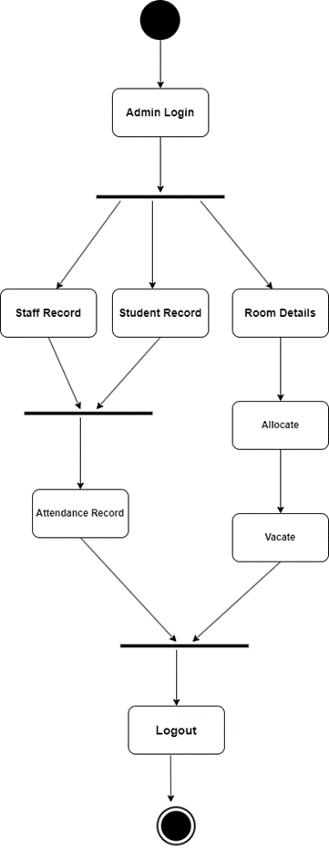

Admin Login Diagram
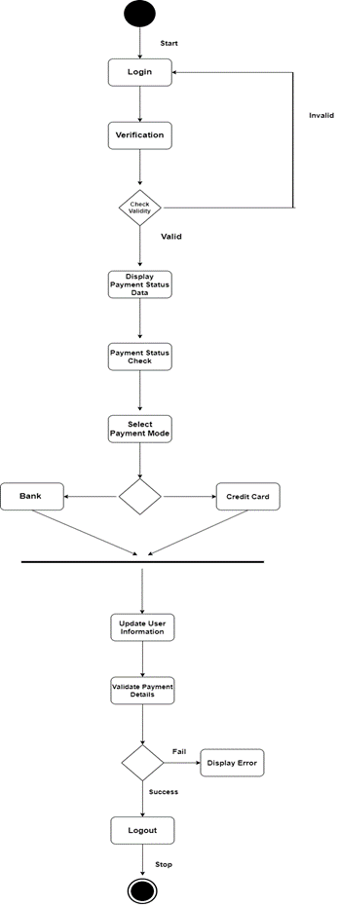
Fee Payment Diagram
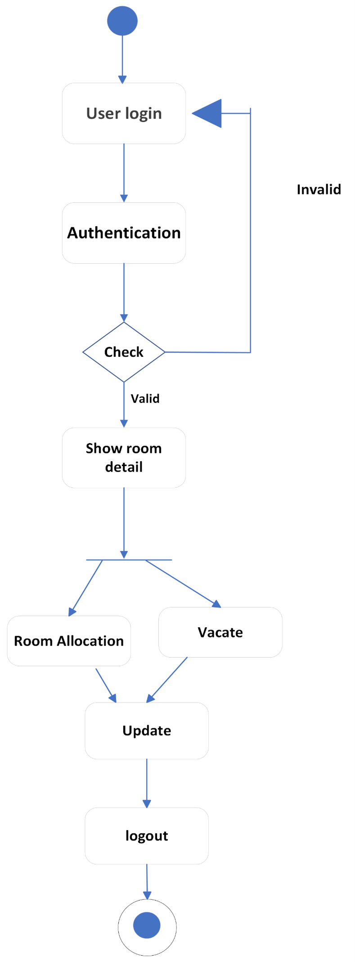

Room Allocation

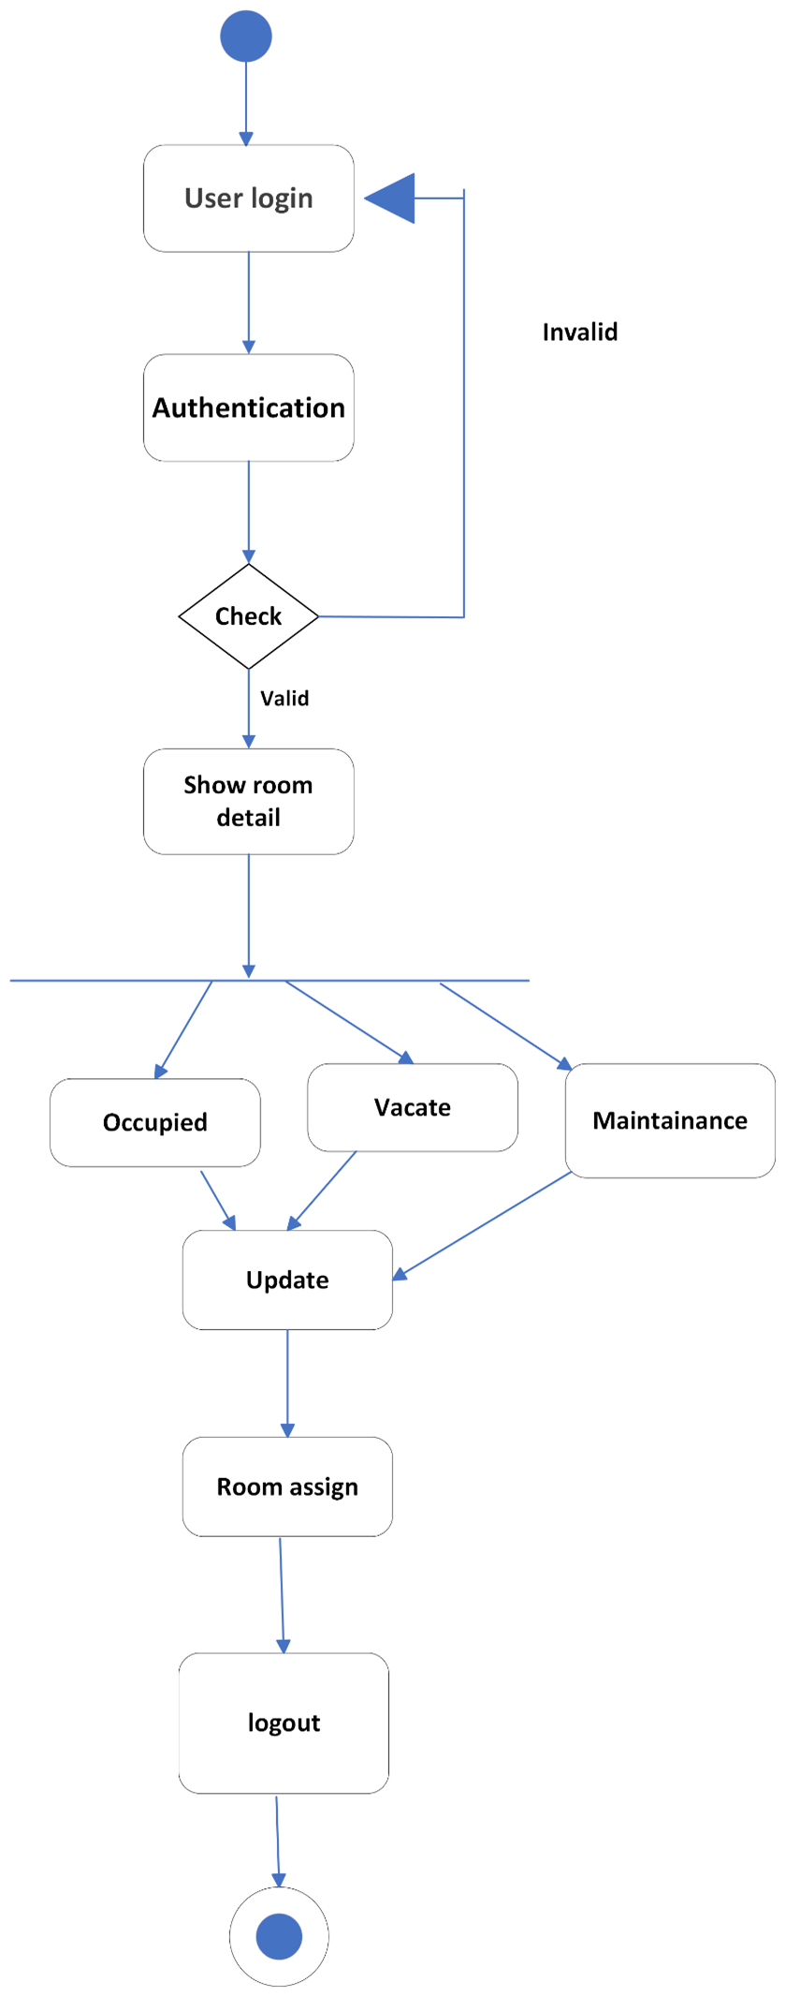

Room Change Diagram

4: Component Diagram:

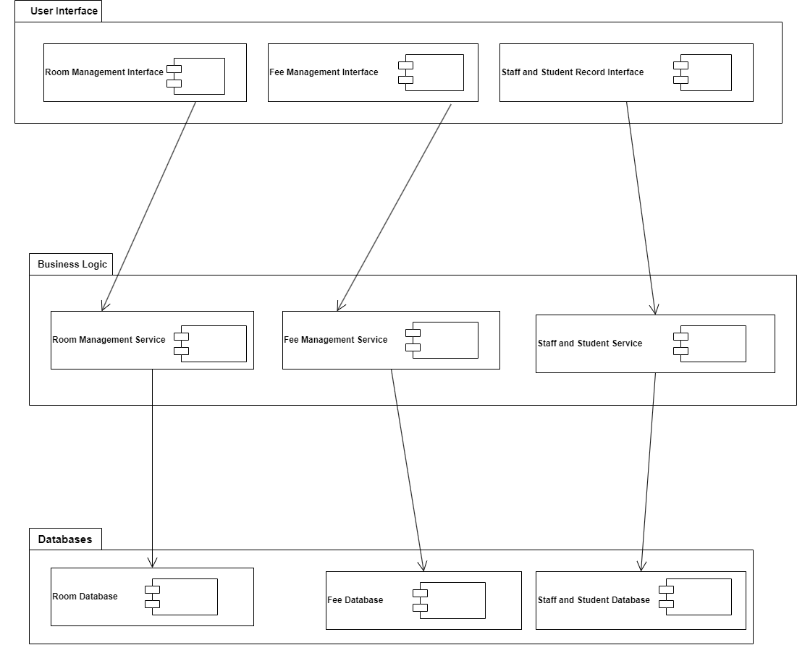

Component Diagram Description:

This component diagram provides a high-level overview of the architecture of the Hostel Management System, illustrating the interaction between various components within the system. The diagram is divided into three main layers: User Interface, Business Logic, and Databases.

1. User Interface
The User Interface layer consists of three primary interfaces that interact with users:
- Room Management Interface: This interface allows users to manage room allocations, view available rooms, and handle room transfer requests.
- Fee Management Interface: This interface enables users to manage fee collections, generate invoices, track payment statuses, and access financial reports.
- Staff and Student Record Interface: This interface provides functionalities for managing staff and student records, including personal details, academic information, and attendance tracking.

2. Business Logic
The Business Logic layer handles the core functionalities and processes of the system. It includes three main services corresponding to the user interfaces:
- Room Management Service: This service processes room allocation and management requests from the Room Management Interface. It interacts with the Room Database to store and retrieve room-related information.
- Fee Management Service: This service manages fee-related operations, processing requests from the Fee Management Interface. It communicates with the Fee Database to handle fee collection and financial data.
- Staff and Student Service: This service deals with managing staff and student records, processing data from the Staff and Student Record Interface. It interacts with the Staff and Student Database to maintain accurate and up-to-date records.

3. Databases
The Database layer comprises three distinct databases, each dedicated to storing specific types of data:
- Room Database: This database stores information about room allocations, availability, and occupancy status. It is accessed by the Room Management Service.
- Fee Database: This database contains data related to fee payments, invoices, and financial reports. It is utilized by the Fee Management Service.
- Staff and Student Database: This database holds comprehensive records of staff and students, including personal information, academic details, and attendance records. It is accessed by the Staff and Student Service.

Interactions
- The User Interfaces interact directly with their respective services in the Business Logic layer. Each interface sends user requests to the corresponding service for processing.
- The Business Logic Services perform the necessary operations and interact with the appropriate databases to store and retrieve data as needed.
- The Databases serve as the data repositories, ensuring that all information is securely stored and efficiently retrieved by the services in the Business Logic layer.
This modular structure ensures that the system is well-organized, scalable, and maintainable. By separating the User Interface, Business Logic, and Database layers, the system can be easily modified or extended without affecting other components

5: Class Diagram:

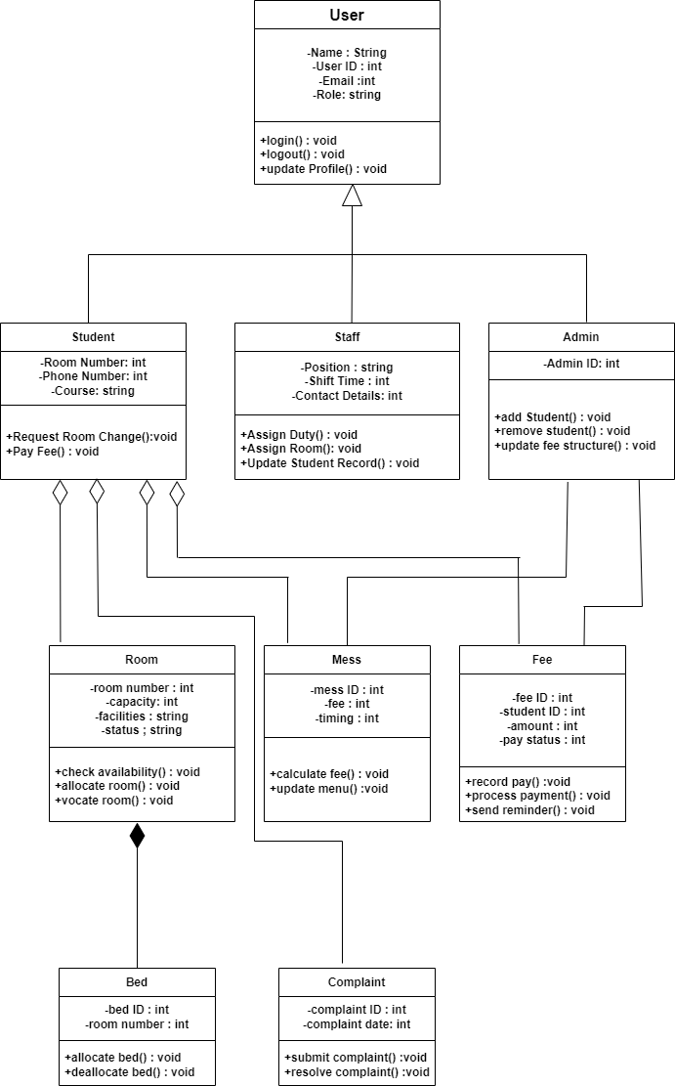

- Function Prototypes:
User:
- login (username, password): Attempts to login the user with provided credentials.
- logout (): Logs the user out of the system.
Student (inherits from User):
- register (personal details, emergency contact): Registers a new student with personal details and emergency contact information.
- view_profile (): Retrieves and displays the student's profile information.
- update_profile(new_details): Updates the student's profile information with provided changes.
- apply_for_room (room_type, preferences): Apply for a room based on type and preferences.
- view_room_allocation (): Checks the current room allocation for the student.
- request_maintenance(complaint_details): Submits a maintenance request for the assigned room.
Staff (inherits from User):
- process_room_application(application): Processes a student's application for room allocation.
- assign_room (student_id, room_id): Assigns a specific room to a student.
- mark_room_maintenance_complete(room_id): Marks a maintenance request for a room as completed.
Admin (inherits from User):
- add_room(room_details): Adds a new room to the hostel with details like type and capacity.
- edit_room (room_id, new_details): Edits the details of an existing room.
- manage_fees(fee_structure): Manages the fee structure for hostel stay and mess.
- view_complaints (): Retrieves and displays a list of pending student complaints.
- generate_reports(report_type): Generates reports based on different criteria like occupancy, fees, etc.
Room:
- get_details (): Retrieves information about the room (type, capacity, amenities).
- is_available (): Checks if the room is currently available for allocation.
Mess:
- register_student(student_id): Registers a student for the mess service.
- deregister_student(student_id): Deregisters a student from the mess service.
- generate_mess_bill(student_id): Generates a mess bill for a specific student.
Fee:
- calculate_total_fee(student_id): Calculates the total fee for a student considering hostel stay and mess (if applicable).
- record_payment(payment_details): Records a payment made by a student.
Bed (optional):
- assign_bed(student_id): Assigns a specific bed within a room to a student (applicable for shared rooms).
- get_bed_occupancy (): Retrieves information on bed occupancy within a room.
Complaint:
- submit_complaint(complaint_details): Allows a user (student or staff) to submit a complaint.
- get_complaint_status(complaint_id): Retrieves the status of a specific complaint.
- Note:
Inheritance is used to avoid code duplication. For example, Student inherits login functionality from the base User class.
- Some classes like Bed might be optional depending on the system's design.
  - Description (Class, Attribute and Functions):
User:
- Represents a system user with login/logout functionality and basic profile information (name, ID, email, role).
- Provides core functionalities like login, logout, and profile updates.
Student (inherits User):
- Extends User with student-specific details (room number, phone, course) and functionalities.
- Manages room requests, fee payments, and can view their profile information.
Staff (inherits User):
- Extends User with staff details (position, shift, contact) and functionalities for managing hostel operations.
- Assigns duties, rooms, updates student records, and interacts with student data.
Admin (inherits User):
- Extends User with highest access for managing students, fees, and overall system settings.
- Adds/removes students, updates fee structure, and oversees core functionalities.
Room:
- Represents a room with details (number, capacity, facilities, status) for student accommodation.
- Provides functions to check availability, allocate/vacate rooms, and manage room status.
Mess:
- Manages the mess service with details (ID, fee, timings).
- Calculates fees, updates menus, and interacts with student mess registrations.
Fee:
- Tracks student fees (ID, student ID, amount, payment status).
- Records payments, processes transactions, and sends payment reminders.
Bed (optional):
- Represents individual beds within rooms (ID, room number) for shared accommodation (optional).
- Manages bed allocation/deallocation within rooms.
Complaint:
- Tracks user complaints (ID, date) submitted by students or staff.
- Allows users to submit complaints and provides functionality for resolving them.
User:
- Attributes: name, id, email, role | Functions: login(), logout(), update_profile()
Student (inherits User):
- Attributes: room_no, phone_no, course | Functions: request_room_change(), pay_fee()
Staff (inherits User):
- Attributes: position, shift_time, contact_details | Functions: assign_duty(), assign_room(), update_student_record()
Admin (inherits User):
- Attributes: N/A | Functions: add_student(), remove_student(), update_fee_structure()
Room:
- Attributes: room_no, capacity, facilities, status | Functions: check_availability(), allocate_room(), vocate_room()
Mess:
- Attributes: id, fee, timings | Functions: calculate_fee(), update_menu()
Fee:
- Attributes: id, student_id, amount, pay_status | Functions: record_payment(), process_payment(), send_reminder()
Bed (optional):
- Attributes: id, room_number | Functions: allocate_bed(), deallocate_bed()
Complaint:
- Attributes: id, complaint_date | Functions: submit_complaint(), resolve_complaint()

- Function Description:
User:
- login(): Allows users (students, staff, admin) to authenticate and access the system.
- logout(): Terminates the user's session and logs them out of the system.
- update_profile(): Enables users to modify their personal information within the system.
Student (inherits User):
- request_room_change(): Allows students to submit requests for changing their assigned room.
- pay_fee(): Provides functionality for students to pay their hostel and mess fees (if applicable).
Staff (inherits User):
- assign_duty(): Enables staff to manage duty schedules for themselves or other staff members.
- assign_room(): Grants staff the ability to allocate rooms to students based on availability and criteria.
- update_student_record(): Provides staff with access to modify student information within the system (e.g., contact details).
Admin (inherits User):
- add_student(): Grants the admin the ability to register new students into the hostel system.
- remove_student(): Allows the admin to deregister students from the hostel system.
- update_fee_structure(): Enables the admin to modify the fee structure for hostel stay, mess services, or other charges.
Room:
- check_availability(): Allows staff or students to check if a specific room is currently available for allocation.
- allocate_room(): Enables staff to assign a room to a student after confirmation.
- vocate_room(): Provides functionality for processing a student's departure from a room upon leaving the hostel.
Mess:
- calculate_fee(): Calculates the mess fee for a student based on their registration and chosen plan.
- update_menu(): Allows authorized personnel to modify the menu offered by the mess service.
Fee:
- record_payment(): Records a student's fee payment made through the system.
- process_payment(): Handles different payment methods and processes fee payments received.
- send_reminder(): Generates and sends automated reminders to students regarding outstanding fees.
Bed (optional):
- allocate_bed(): Assigns a specific bed within a room to a student (applicable for shared rooms).
- deallocate_bed(): Processes the release of a bed when a student vacates a shared room.
Complaint:
- submit_complaint(): Allows students or staff to submit complaints related to hostel facilities, services, or other issues.
resolve_complaint(): Enables authorized personnel to address submitted complaints and mark them as resolved.
3: Relationships:
Inheritance Relationship:
- User (Base Class): This is the foundation class representing all system users. It defines core functionalities like login, logout, and profile management.
- Student, Staff, Admin (Derived Classes): These classes inherit functionalities from the User class. They represent specific user types with additional functionalities relevant to their roles.
Cardinality:
- A single User can have one role (Student, Staff, or Admin) - One-to-One between User and the inherited role within each derived class.
Aggregation Relationship:
- Room and Student: A room can accommodate multiple students (One-to-Many). However, a student can be assigned to only one room at a time (Many-to-One). This represents a temporary association. Students can change rooms, and rooms can exist without students.
- Student and Mess: A student can choose to register for the mess service (One-to-One) or not participate (One-to-Zero). This is an optional association.
- Student and Complaint: A student can submit multiple complaints (One-to-Many). Each complaint is associated with a single student (Many-to-One). This represents an ongoing association for tracking issues.
Cardinality:
- One Student can have Many Complaints and vice versa (One-to-Many).
- One Student can be enrolled in Zero or One Mess service (One-to-Zero or One-to-One).
- One Room can accommodate Many Students over time (One-to-Many).
Composition Relationship:
- Student and Fee: A student will have one or more fees associated with their stay (One-to-Many). However, a fee record wouldn't exist without a student. Fees are dependent on the student's existence.
- Bed and Room: A bed exists within a room (One-to-One). A room can't exist without a bed (although it might not be occupied). The lifecycle of a bed is tied to the room.
Cardinality:
- One Student can have Many Fees (One-to-Many).
- One Bed must belong to One Room (One-to-One).
Note:
The Bed class might be optional depending on the system design. If rooms are not shared, there might not be a need to track individual beds.

6: Sequence Diagram:

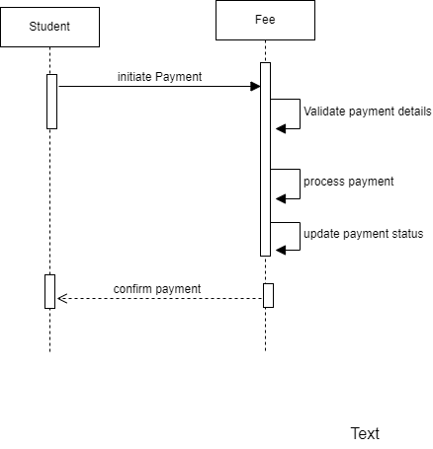

Fee Payment Diagram

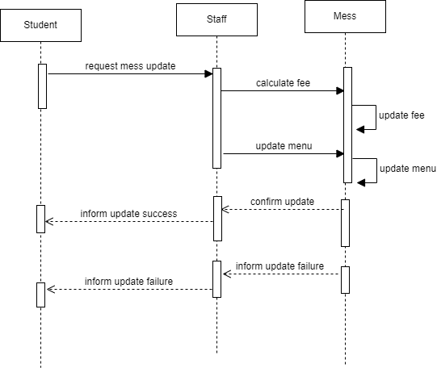

Mess Management Record Diagram

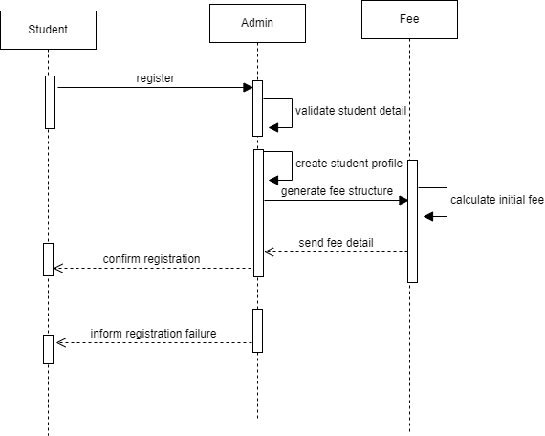

Student Login Diagram

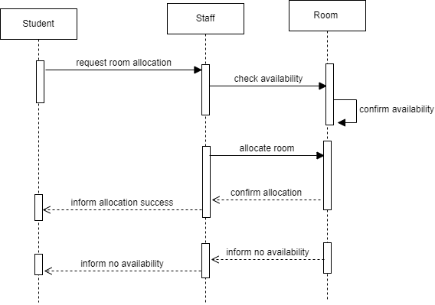

Room Allocation Diagram

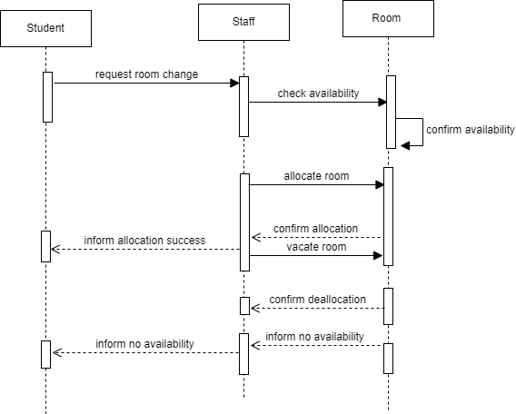

Room Change Diagram

7: State Diagram:

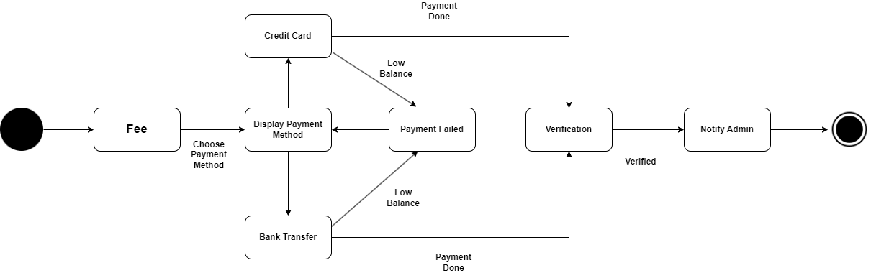

Fee Diagram

Explanation of the Fee State Transition Diagram
This state transition diagram illustrates the states and transitions involved in the fee payment process within the Hostel Management System. The diagram showcases the various states a fee object can go through from initiation to completion, including any potential failures and verification steps.

States and Transitions:
- Fee (Initial State):
  - Description: This is the initial state where the fee payment process begins.
  - Transition: The user initiates the payment process, leading to the next state where the payment method is chosen.
- Display Payment Method:
  - Description: In this state, the system displays the available payment methods to the user.
  - Transition:
    - The user can choose between:
      - Credit Card: Transition to the Credit Card state.
      - Bank Transfer: Transition to the Bank Transfer state.
- Credit Card:
  - Description: This state handles the credit card payment process.
  - Transitions:
    - Payment Done: If the payment is successful, transition to the Verification state.
    - Low Balance: If the payment fails due to insufficient funds, transition to the Payment Failed state.
- Bank Transfer:
  - Description: This state handles the bank transfer payment process.
  - Transitions:
    - Payment Done: If the payment is successful, transition to the Verification state.
    - Low Balance: If the payment fails due to insufficient funds, transition to the Payment Failed state.
- Payment Failed:
  - Description: This state indicates that the payment attempt has failed, possibly due to low balance or other issues.
  - Transition:
    - Display Payment Method: The user is prompted to choose a payment method again.
- Verification:
  - Description: In this state, the system verifies the payment details and confirms the transaction.
  - Transition:
    - Verified: Once the payment is verified, transition to the Notify Admin state.
- Notify Admin:
  - Description: This state involves notifying the administrator of the successful payment.
  - Transition: This is the final state, indicating that the fee payment process is complete.
- Final State:
  - Description: This represents the completion of the fee payment process.

Summary of Objects and States:
- Objects: The primary object in this diagram is the fee payment process, which transitions through various states based on user actions and payment outcomes.
- States: The key states include:
  - Initial state (Fee)
  - Display Payment Method
  - Credit Card
  - Bank Transfer
  - Payment Failed
  - Verification
  - Notify Admin
  - Final state
Each state represents a specific stage in the fee payment process, and the transitions depict the flow based on user interactions and payment results. The system ensures that users have multiple attempts to complete the payment in case of failures, and proper verification and notification mechanisms are in place to finalize the process.

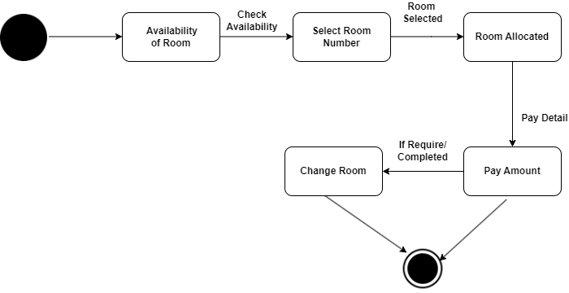

Room State Transition Diagram

Explanation of the Room State Transition Diagram
This state transition diagram illustrates the states and transitions involved in the room process within the Hostel Management System. The diagram outlines the steps from checking room availability to the final allocation and potential room change requests.

States and Transitions:
- Availability of Room (Initial State):
  - Description: This is the initial state where the process begins with checking the availability of rooms.
  - Transition: The user initiates the process by checking the availability, leading to the next state.
- Check Availability:
  - Description: In this state, the system checks the current availability of rooms.
  - Transition:
    - If rooms are available, transition to the Select Room Number state.
- Select Room Number:
  - Description: In this state, the user selects a specific room number from the available options.
  - Transition:
    - Once a room is selected, transition to the Room Selected state.
- Room Selected:
  - Description: This state indicates that a room has been selected by the user.
  - Transition:
    - The system allocates the selected room to the user, moving to the Room Allocated state.
- Room Allocated:
  - Description: In this state, the selected room is officially allocated to the user.
  - Transition:
    - The user is required to make the payment, leading to the Pay Amount state.
- Pay Amount:
  - Description: This state involves the payment process for the allocated room.
  - Transitions:
    - If the payment is completed, the process can end, reaching the Final State.
    - If the user requests a room change, transition to the Change Room state.
- Change Room:
  - Description: In this state, the user can request a change of room.
  - Transitions:
    - If a room change is processed and completed, it leads to the Final State.
    - If the room change is not required or completed, it transitions back to Pay Amount for payment processing of the newly allocated room.
- Final State:
  - Description: This represents the completion of the room allocation process.

Summary of Objects and States:
- Objects: The primary object in this diagram is the room allocation process, which transitions through various states based on user actions and room availability.
- States: The key states include:
  - Initial state (Availability of Room)
  - Check Availability
  - Select Room Number
  - Room Selected
  - Room Allocated
  - Pay Amount
  - Change Room
  - Final state
Each state represents a specific stage in the room process, and the transitions depict the flow based on user interactions and room availability. The system ensures that users can select rooms, make payments, and request changes efficiently, with clear transitions to handle each scenario.

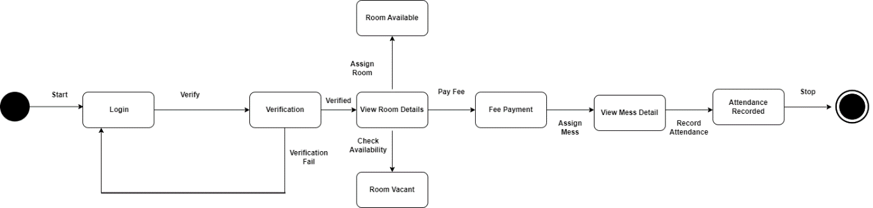

Student Diagram

- Start: The process begins here, represented by the black circle on the left.
- Login: The user starts by logging into the system. This is the first step.
- Verification: After logging in, the user's credentials are verified. There are two possible outcomes from this state:
  - If verification is successful ("Verified"), the process moves to "View Room Details."
  - If verification fails ("Verification Fail"), the process loops back to "Login," prompting the user to try again.
- View Room Details: Once verified, the user can view room details. At this point, the system checks the availability of rooms.
- Room Available / Room Vacant:
  - If a room is available, the system transitions to "Room Available," where a room can be assigned to the user.
  - If no room is available, the system transitions to "Room Vacant," indicating that the user needs to check availability again or take other actions (not detailed in the diagram).
- Assign Room: If a room is available and assigned, the process returns to "View Room Details" for confirmation.
- Fee Payment: After viewing and confirming the room details, the user proceeds to pay the fee.
- Assign Mess: After the fee is paid, the system assigns a mess (dining facility) to the user.
- View Mess Detail: The user can then view details about the assigned mess.
- Record Attendance: Finally, the user's attendance is recorded, completing the process.
- Attendance Recorded: This is the last step, where the attendance has been successfully recorded, leading to the end of the process (indicated by the black circle on the right).

Summary of Transitions
- From "Login" to "Verification"
- From "Verification" to either "View Room Details" (if verified) or back to "Login" (if verification fails)
- From "View Room Details" to "Room Available" or "Room Vacant" (based on availability)
- From "Room Available" to "Assign Room" and then back to "View Room Details"
- From "View Room Details" to "Fee Payment"
- From "Fee Payment" to "Assign Mess"
- From "Assign Mess" to "View Mess Detail"
- From "View Mess Detail" to "Record Attendance"
- From "Record Attendance" to "Attendance Recorded" (end of the process)

